Practical 7

# Student Details

* Name : Tushar Harsora
* Roll : 19BCE509

# Aim

The Aim of this practical was to implement the heap using the linked data structure. The version of heap that is implemented here is called leftist heap. This datastructure Is implemented like. Every node has ofcourse left and right pointers but one extra number which is “rank” which is distance of node from nearest leaf. The insertion and deletion takes 𝒪 $\left(logN\right)$

The build heap can be done in 𝒪 $\left(N\right).$

# Code

* Leftist Heap (LeftistHeap.h)

#ifndef LEFTIST_HEAP_H

#define LEFTIST_HEAP_H

#include <iostream>

#include <cassert>

template<typename Key>

struct heap_node {

private:

constexpr static size_t space_block = 7;

public:

Key key;

size_t rank;

heap_node<Key>* left;

heap_node<Key>* right;

heap_node(const Key& key) : key(key), rank(1), left(nullptr), right(nullptr) { }

friend heap_node<Key>* merge(heap_node<Key>* l, heap_node<Key>* r) {

if (l == nullptr)

return r;

if (r == nullptr)

return l;

if (l->key < r->key) {

l->right = merge(l->right, r);

assert(l->right);

if (!l->left || l->left->rank < l->right->rank) {

std::swap(l->left, l->right);

}

l->rank = l->right ? l->right->rank + 1 : 1;

return l;

}

else {

r->right = merge(r->right, l);

assert(r->right);

if (!r->left || r->left->rank < r->right->rank) {

std::swap(r->left, r->right);

}

r->rank = r->right ? r->right->rank + 1 : 1;

return r;

}

assert(false);

}

friend std::ostream& print_helper(std::ostream& stream, const heap_node<Key>* ptr, size_t spaces = 0) {

if (!ptr)

return stream;

spaces += space_block;

print_helper(stream, ptr->right, spaces);

stream << '\n';

for (int i = 0; i < spaces; i++)

stream << ' ';

stream << ptr->key << " (" << ptr->rank << ")";

print_helper(stream, ptr->left, spaces);

}

~heap_node() {

if (left) {

delete left;

}

if (right) {

delete right;

}

}

};

template<typename Key>

struct leftist_heap {

private:

heap_node<Key>* m_root;

heap_node<Key>* _insert(heap_node<Key>* root, const Key& key) {

if (!root) {

return new heap_node<Key>(key);

}

if (key < root->key) {

heap_node<Key>* new_node = new heap_node<Key>(key);

new_node->left = root;

return new_node;

}

if (root->right && key > root->right->key) {

root->right = _insert(root->right, key);

assert(root->left && root->right);

if (root->left->rank < root->right->rank)

std::swap(root->left, root->right);

root->rank = root->right->rank + 1;

return root;

}

heap_node<Key>* new_node = new heap_node<Key>(key);

if (root->left == nullptr) {

root->left = new_node;

return root;

}

assert(root->right == nullptr);

assert(root->rank == 1);

root->right = new_node;

root->rank = 2;

assert(root->left && root->right);

if (root->left->rank < root->right->rank) {

std::swap(root->left, root->right);

}

return root;

}

public:

leftist_heap() : m_root(nullptr) { }

void insert(const Key& key) {

m_root = _insert(m_root, key);

// We could also create new heap with one node and merge with existing tree.

// I wrote this merge function later so i already had insert both implementations are fine

// auto new_node = new heap_node<Key>(key);

// m_root = merge(m_root, new_node);

}

void pop() {

heap_node<Key>* left_child = m_root->left;

heap_node<Key>* right_child = m_root->right;

m_root->left = nullptr;

m_root->right = nullptr;

delete m_root; // resetting left, right was necessary because delete operator deletes childs recursively

m_root = merge(left_child, right_child);

}

const Key& top() const {

return m_root->key;

}

bool empty() const { return m_root == nullptr; }

void vertical_print() const {

print_helper(std::cout, m_root);

}

~leftist_heap() {

delete m_root;

m_root = nullptr;

}

};

#endif // LEFTIST_HEAP_H

* LeftistHeap Test (main function)

#include <iostream>

#include "LeftistHeap.h"

using namespace std;

int main() {

leftist_heap<int> hp;

for (int i = 0; i < 10; i++)

hp.insert(i + 1);

std::cout << "After Inserting [0-10]\n";

hp.vertical_print();

std::cout << "\n";

cout << "Current Min Element : " << hp.top() << "\n";

hp.pop();

cout << "After Poping Min Element\n";

hp.vertical_print();

return 0;

}

# Inputs

This Program Doesn’t take any inputs.

The Program itself inserts 1 to 10 Numbers in heap and displays them.

Then deletes one element and prints modified heap. The Number in bracket in output is “rank” of node.

# Output

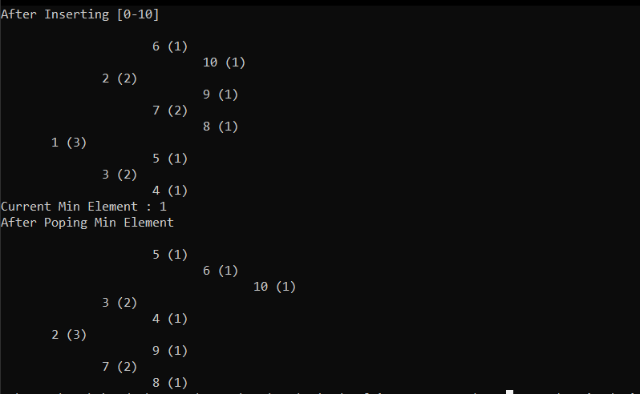

# Conclusion

Here we learned about the merge, insert, delete functions of leftist heap. It takes other approach for leftist heap is it tries to be unbalanced and then rebalances itself. Here right child’s “rank” is always lower than “rank” of left child for every immediate node.